FOURTH GRADE MATHEMATICS UNIT 3 STANDARDS
Dear Parents,

We want to make sure that you have an understanding of the mathematics your child will be learning this year. Below you will find the standards we will be learning in Unit Three. Each standard is in bold print and underlined and below it is an explanation with student examples. Your child is not learning math the way we did when we were in school, so hopefully this will assist you when you help your child at home. Please let your teacher know if you have any questions.
☺

MGSE4.NF.1 Explain why a fraction a/b is equivalent to a fraction (n × a)/(n × b) by using visual fraction models, with attention to how the number and size of the parts differ even though the two fractions themselves are the same size. Use this principle to recognize and generate equivalent fractions.

This standard refers to visual fraction models. This includes area models, number lines or it could be a collection/set model. This standard extends the work in third grade by using additional denominators (5, 10, 12, and 100).

This standard addresses equivalent fractions by examining the idea that equivalent fractions can be created by multiplying both the numerator and denominator by the same number or by dividing a shaded region into various parts.
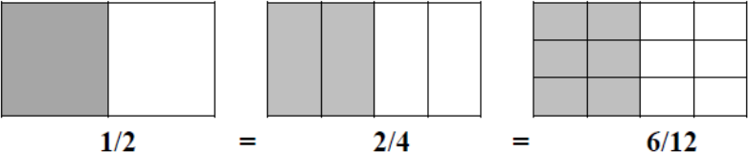
Example:

Technology Connection: http://illuminations.nctm.org/activitydetail.aspx?id=80

MGSE4.NF.2 Compare two fractions with different numerators and different denominators, e.g., by creating common denominators or numerators, or by comparing to a benchmark fraction such as 1/2. Recognize that comparisons are valid only when the two fractions refer to the same whole. Record the results of comparisons with symbols >, =, or <, and justify the conclusions, e.g., by using a visual fraction model.

This standard calls students to compare fractions by creating visual fraction models or finding common denominators or numerators. Students’ experiences should focus on visual fraction models rather than algorithms. Students should learn to draw fraction models to help them compare. Students must also recognize that they must consider the size of the whole when comparing fractions (i.e., 1/2 and 1/8 of two medium pizzas is very different from 1/2 of one medium and 1/8 of one large).

Example:
Use patterns blocks.
- If a red trapezoid is one whole, which block shows 1/3?
- If the blue rhombus is 1/3, which block shows one whole?
- If the red trapezoid is one whole, which block shows 2/3?

Example:
Mary used a 12 × 12 grid to represent 1 and Janet used a 10 × 10 grid to represent 1. Each girl shaded grid squares to show ¼. How many grid squares did Mary shade? How many grid squares did Janet shade? Why did they need to shade different numbers of grid squares?
Possible solution: Mary shaded 36 grid squares; Janet shaded 25 grid squares. The total number of little squares is different in the two grids, so ¼ of each total number is different.
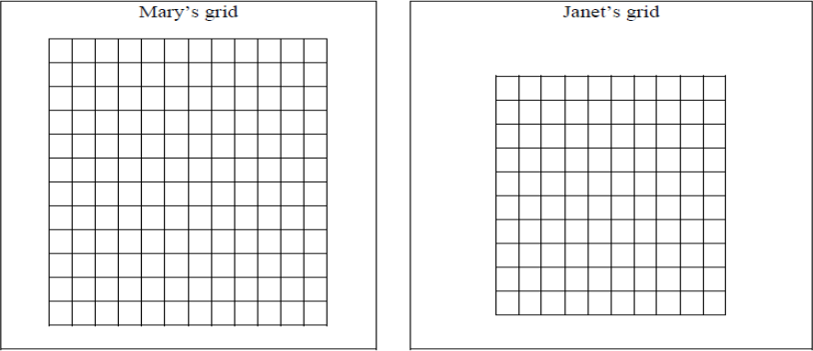

Example:
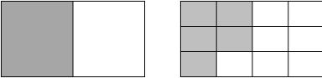
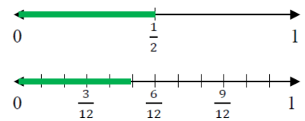
There are two cakes on the counter that are the same size. The first cake has 1/2 of it left. The second cake has 5/12 left. Which cake has more left?

Student 1: Area Model
The first cake has more left over. The second cake has 5/12 left which is smaller than 1/2.
Student 2: Number Line Model
The first cake has more left over: 1/2 is bigger than 5/12.
Student 3: Verbal Explanation
I know that 6/12 equals 1/2, and 5/12 is less than 1/2. Therefore, the second cake has less left
over than the first cake. The first cake has more left over.

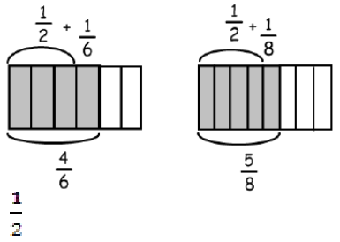Example:
When using the benchmark of to compare to and , you could use diagrams such as these:

is larger than , while is larger than . Since is greater than , is the greater fraction.

Common Misconceptions
Students think that when generating equivalent fractions they need to multiply or divide either the numerator or denominator, such as, changing 12 to sixths. They would multiply the denominator by 3 to get 16, instead of multiplying the numerator by 3 also. Their focus is only on the multiple of the denominator, not the whole fraction.
Students need to use a fraction in the form of one such as 33 so that the numerator and denominator do not contain the original numerator or denominator.

MGSE4.MD.2 Use the four operations to solve word problems involving distances, intervals of time, liquid volumes, masses of objects, and money, including problems involving simple fractions or decimals, and problems that require expressing measurements given in a larger unit in terms of a smaller unit. Represent measurement quantities using diagrams such as number line diagrams that feature a measurement scale.

