Dear Parents,
FOURTH GRADE MATHEMATICS UNIT 4 STANDARDS

We want to make sure that you have an understanding of the mathematics your child will be learning this year. Below you will find the standards we will be learning in Unit Four. Each standard is in bold print and underlined and below it is an explanation with student examples. Your child is not learning math the way we did when we were in school, so hopefully this will assist you when you help your child at home. Please let your teacher know if you have any questions. ☺

MGSE.4.NF.3 Understand a fraction a/b with a > 1 as a sum of fractions 1/b.

- Understand addition and subtraction of fractions as joining and separating parts referring to the same whole.
A fraction with a numerator of one is called a unit fraction. When students investigate fractions other than unit fractions, such as 2/3, they should be able to join (compose) or separate (decompose) the fractions of the same whole.
Example:
Being able to visualize this decomposition into unit fractions helps students when adding or subtracting fractions. Students need multiple opportunities to work with mixed numbers and be able to decompose them in more than one way. Students may use visual models to help develop this understanding.
Example: ? → →
Example of word problem:
Mary and Lacey decide to share a pizza. Mary ate and Lacey ate of the pizza. How much of the pizza did the girls eat together?

Possible solution: The amount of pizza Mary ate can be thought of a or + + . The amount of pizza Lacey ate can be thought of a + . The total amount of pizza they ate is + + + + or of the pizza. A fraction with a numerator of one is called a unit fraction. When students investigate fractions other than unit fractions, such as 2/3, they should be able to join (compose) or separate (decompose) the fractions of the same whole.
Example:
Being able to visualize this decomposition into unit fractions helps students when adding or subtracting fractions. Students need multiple opportunities to work with mixed numbers and be able to decompose them in more than one way. Students may use visual models to help develop this understanding.

Example: ? → →

Example of word problem:
Mary and Lacey decide to share a pizza. Mary ate and Lacey ate of the pizza. How much of the pizza did the girls eat together?
Possible solution: The amount of pizza Mary ate can be thought of a or + + . The amount of pizza Lacey ate can be thought of a + . The total amount of pizza they ate is + + + + or of the pizza.
- Decompose a fraction into a sum of fractions with the same denominator in more than one way, recording each decomposition by an equation. Justify decompositions, e.g., by using a visual fraction model. Examples: 3/8 = 1/8 + 1/8 + 1/8 ; 3/8 = 1/8 + 2/8 ; 2 1/8 = 1 + 1 + 1/8 = 8/8 + 8/8 + 1/8.
Students should justify their breaking apart (decomposing) of fractions using visual fraction models. The concept of turning mixed numbers into improper fractions needs to be emphasized using visual fraction models.
Example:
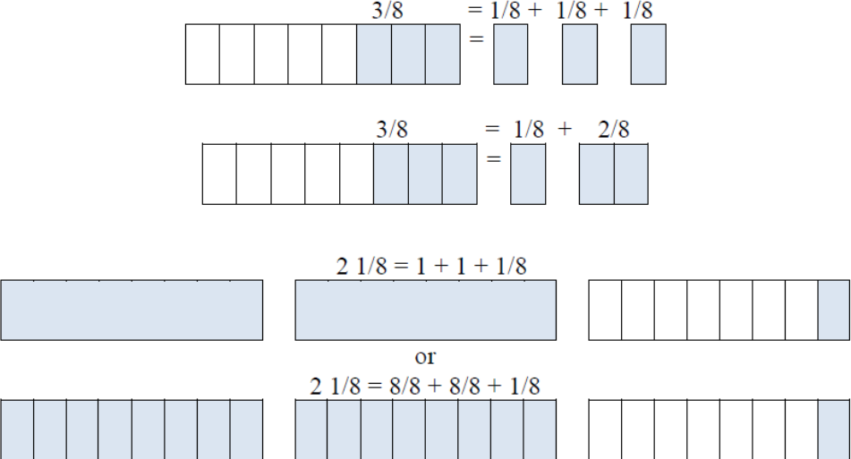

Add and subtract mixed numbers with like denominators, e.g., by replacing each mixed number with an equivalent fraction, and/or by using properties of operations and the relationship between addition and subtraction.
A separate algorithm for mixed numbers in addition and subtraction is not necessary. Students will tend to add or subtract the whole numbers first and then work with the fractions using the same strategies they have applied to problems that contained only fractions.

Example:
Susan and Maria need feet of ribbon to package gift baskets. Susan has feet of ribbon and Maria has feet of ribbon. How much ribbon do they have altogether? Will it be enough to complete the project? Explain why or why not.
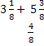
The student thinks: I can add the ribbon Susan has to the ribbon Maria has to find out how much ribbon they have altogether. Susan has feet of ribbon and Maria has feet of ribbon. I can write this as . I know they have 8 feet of ribbon by adding the 3 and 5. They also have and which makes a total of more. Altogether they have feet of ribbon. 8 is larger than so they will have enough ribbon to complete the project. They will even have a little extra ribbon left: foot.
Example:
Trevor has pizzas left over from his soccer party. After giving some pizza to his friend, he has of a pizza left. How much pizza did Trevor give to his friend?
Possible solution: Trevor had pizzas to start. This is of a pizza. The x’s show the pizza he has left which is pizzas or pizzas. The shaded rectangles without the x’s are the pizza he gave to his friend which is or pizzas.
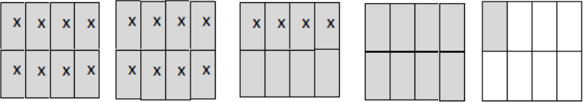
Mixed numbers are introduced for the first time in 4th Grade. Students should have ample experiences of adding and subtracting mixed numbers where they work with mixed numbers or convert mixed numbers into improper fractions.
Example:
While solving the problem, , students could do the following:
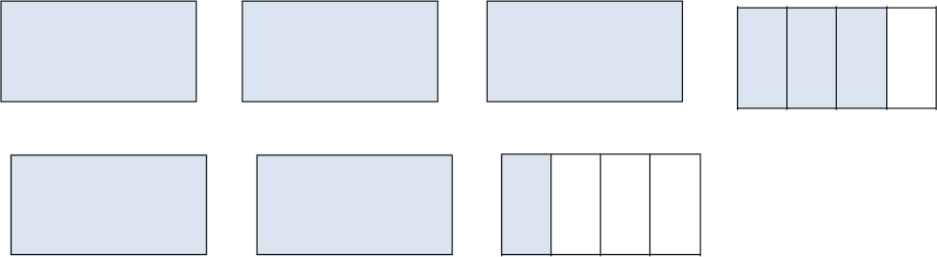

Student 1: | 3 + 2 = 5 and |  | , so 5 + 1 = 6.
Student 2: | , so |  | .
Student 3: | and | , so | .

Solve word problems involving addition and subtraction of fractions referring to the same whole and having like denominators, e.g., by using visual fraction models and equations to represent the problem.
Example:
A cake recipe calls for you to use cup of milk, cup of oil, and cup of water. How much liquid was needed to make the cake?
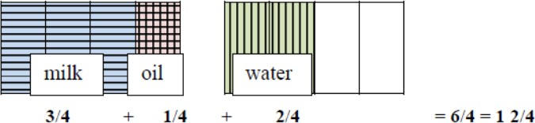

MGSE4.NF.4 Apply and extend previous understandings of multiplication to multiply a fraction by a whole number.
- Understand a fraction a/b as a multiple of 1/b. For example, use a visual fraction model to represent 5/4 as the product 5 × (1/4), recording the conclusion by the equation 5/4 = 5 × (1/4).
This standard builds on students’ work of adding fractions and extending that work into multiplication. Example:
Number line:
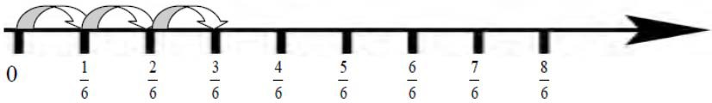
Area model:
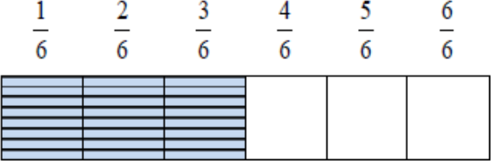

- Understand a multiple of a/b as a multiple of 1/b, and use this understanding to multiply a fraction by a whole number. For example, use a visual fraction model to express 3 × (2/5) as 6 × (1/5), recognizing this product as 6/5. (In general, n × (a/b) = (n × a)/b.)
This standard extended the idea of multiplication as repeated addition. For example,
.
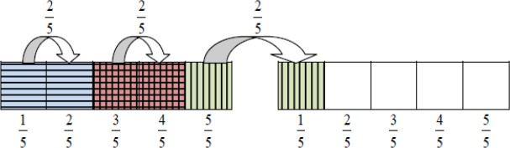
Students are expected to use and create visual fraction models to multiply a whole number by a fraction.

- Solve word problems involving multiplication of a fraction by a whole number, e.g., by using visual fraction models and equations to represent the problem. For example, if each person at a party will eat 3/8 of a pound of roast beef, and there will be 5 people at the party, how many pounds of roast beef will be needed? Between what two whole numbers does your answer lie?
This standard calls for students to use visual fraction models to solve word problems related to multiplying a whole number by a fraction.
Example:
In a relay race, each runner runs ½ of a lap. If there are 4 team members how long is the race?
Student 1 – Draws a number line showing 4 jumps of ½:

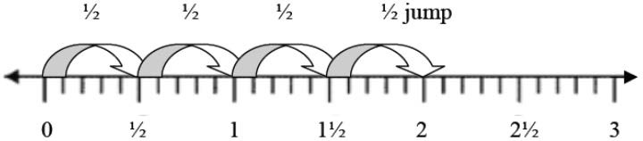

Student 2 – Draws an area model showing 4 pieces of ½ joined together to equal 2:

Student 3 – Draws an area model representing 4 × ½ on a grid,
dividing one row into ½ to represent the multiplier:

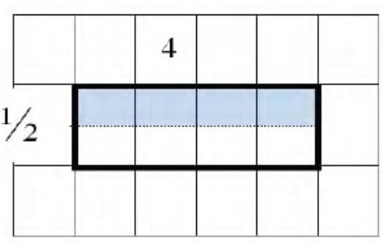
Example:
Heather bought 12 plums and ate 13 of them. Paul bought 12 plums and ate 14 of them. Which statement is true? Draw a model to explain your reasoning.
  - Heather and Paul ate the same number of plums.
  - Heather ate 4 plums and Paul ate 3 plums.
  - Heather ate 3 plums and Paul ate 4 plums.
  - Heather had 9 plums remaining.

Examples:
Students need many opportunities to work with problems in context to understand the connections between models and corresponding equations. Contexts involving a whole number times a fraction lend themselves to modeling and examining patterns.

1.
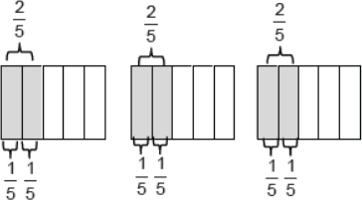
2. If each person at a party eats 38 of a pound of roast beef, and there are 5 people at the party, how many pounds of roast beef are needed? Between what two whole numbers does your answer lie?
A student may build a fraction model to represent this problem:
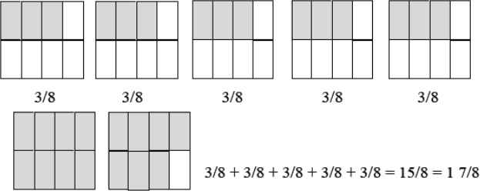

Common Misconceptions
Students think that it does not matter which model to use when finding the sum or difference of fractions. They may represent one fraction with a rectangle and the other fraction with a circle. They need to know that the models need to represent the same whole.

MGSE4.MD.2 Use the four operations to solve word problems involving distances, intervals of time, liquid volumes, masses of objects, and money, including problems involving simple fractions or decimals, and problems that require expressing measurements given in a larger unit in terms of a smaller unit. Represent measurement quantities using diagrams such as number line diagrams that feature a measurement scale.

